5. Create a simple cloud software application for Library book reservation system for SIMATS library using any Cloud Service Provider to demonstrate SaaS

**Solution:**

Select software:

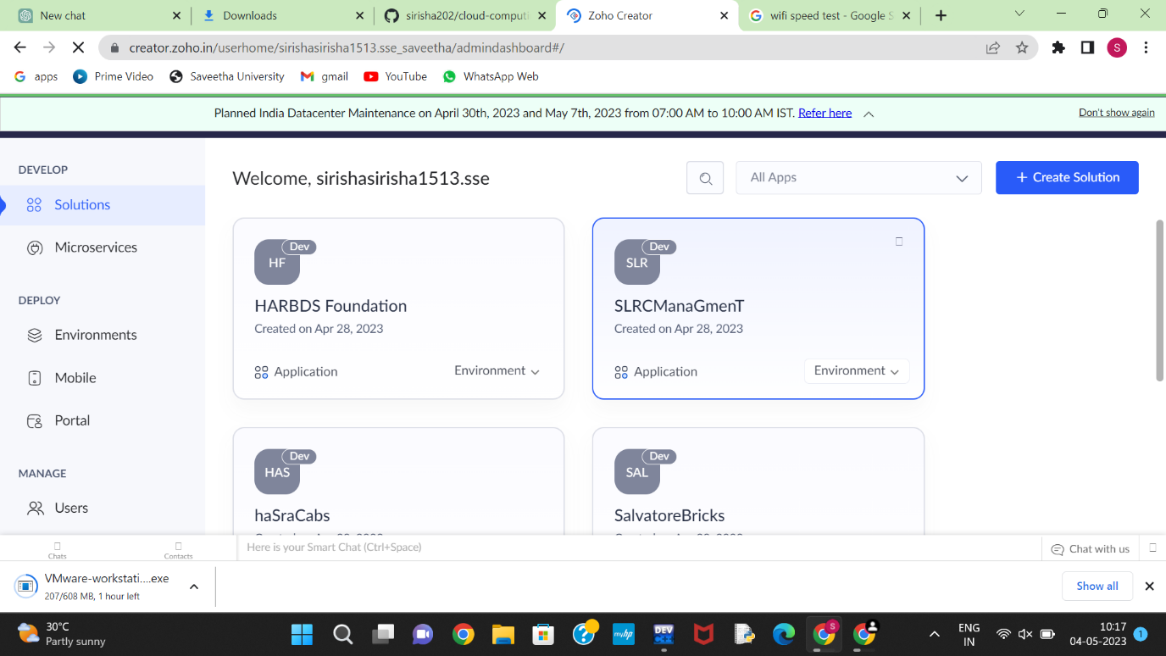

Application:

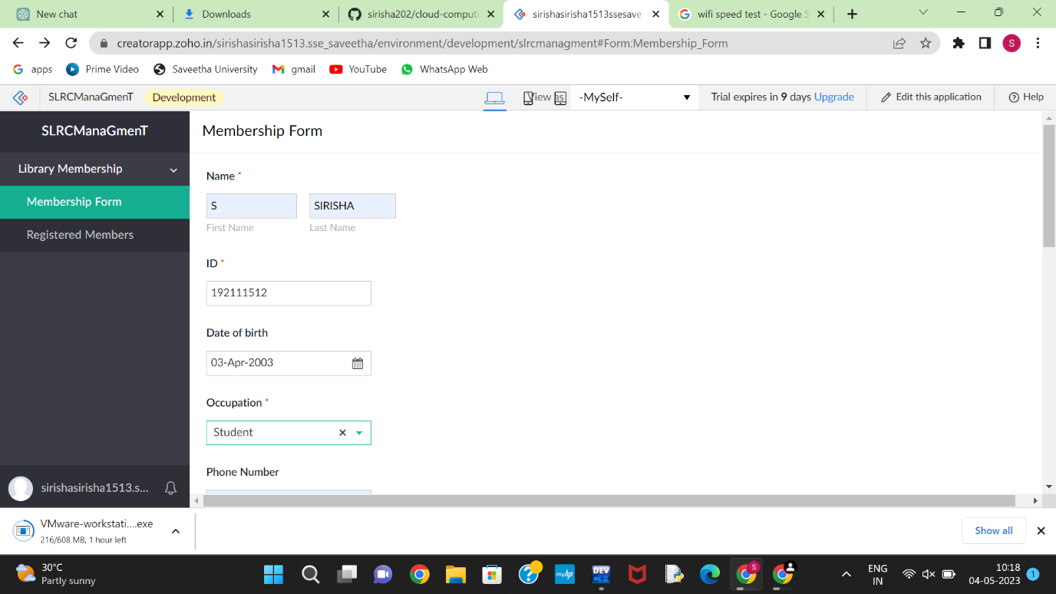

Output:

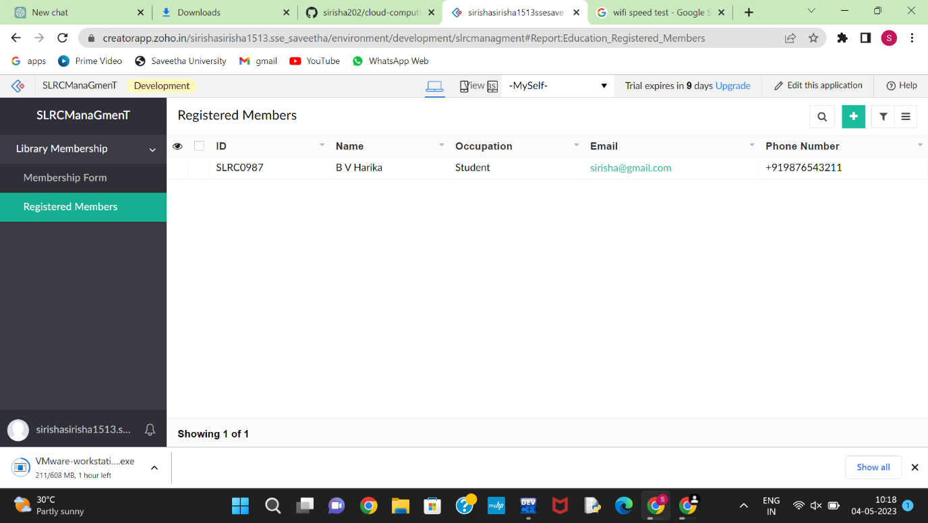

1. Create a simple cloud software application and provide it as a service using any Cloud Service Provider to demonstrate Software as a Service (SaaS).

**Solution:**

Select software:

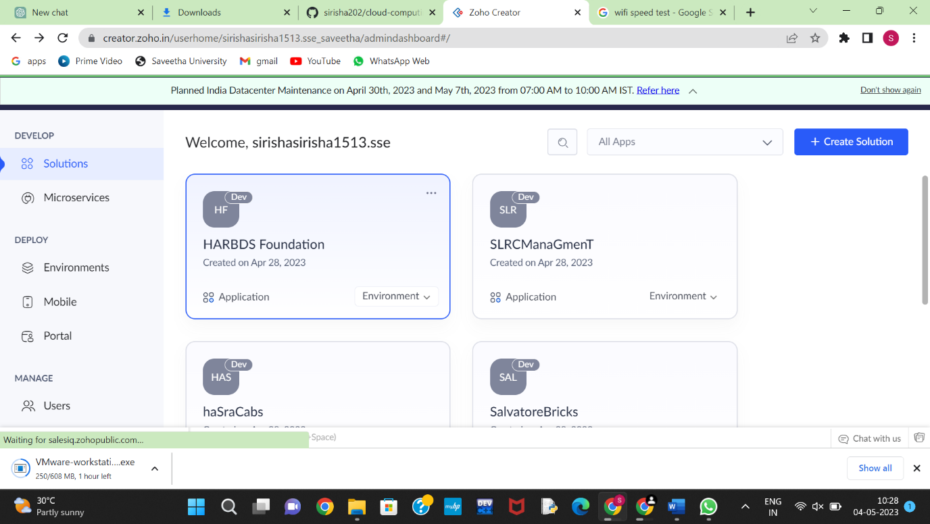

Application form:

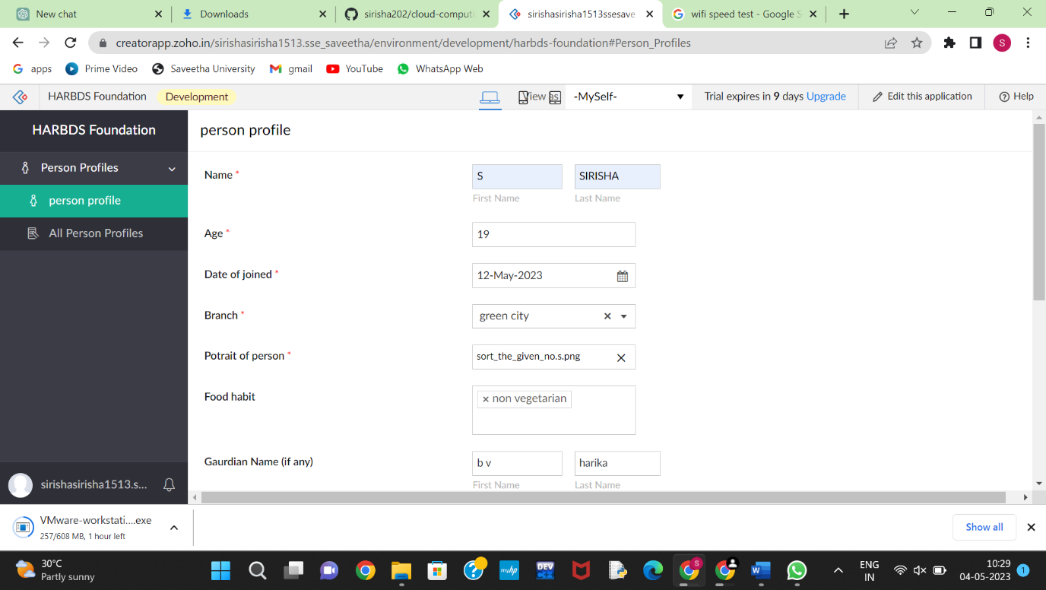

Output:

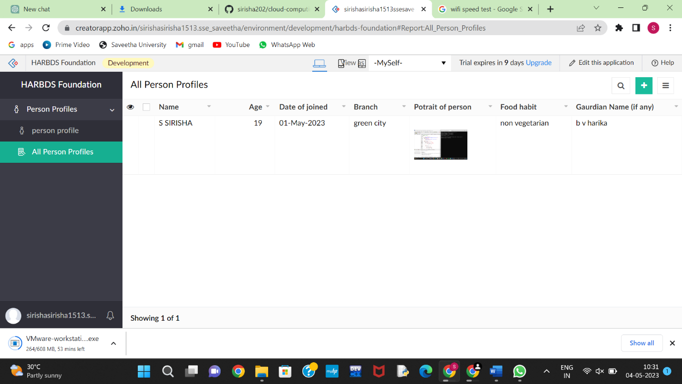

1. Create a simple cloud software application for Flight Reservation System using any Cloud Service Provider to demonstrate SaaS

**Solution:**

Select software:

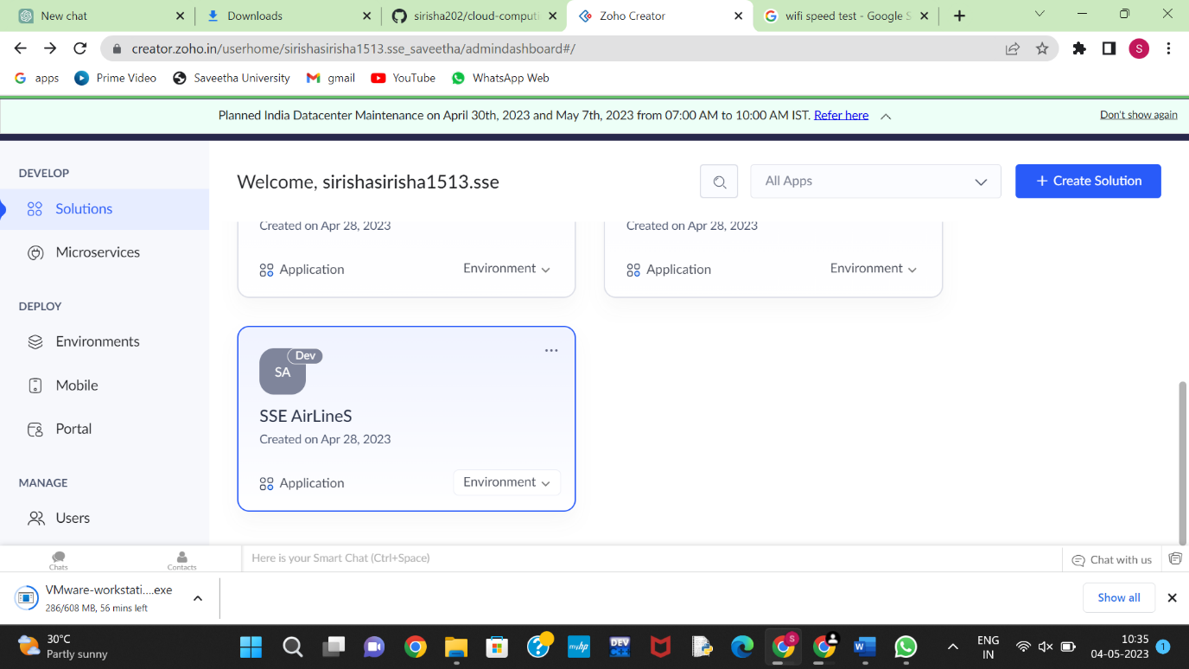

Application form:

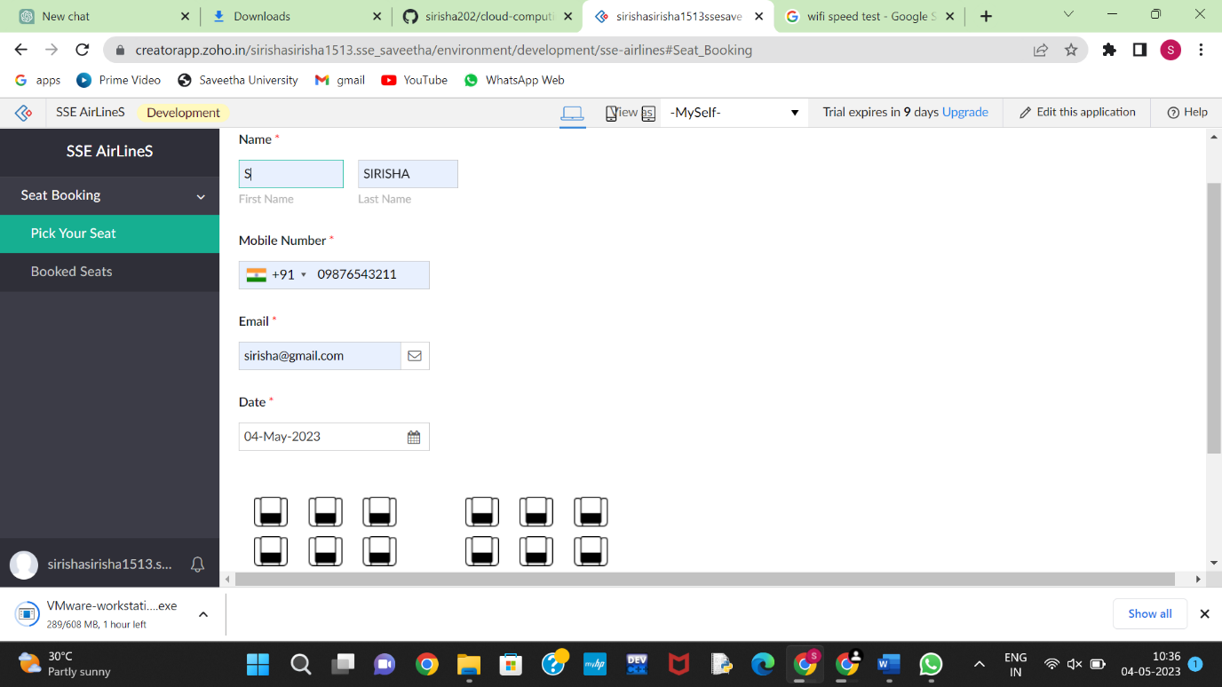

Output:

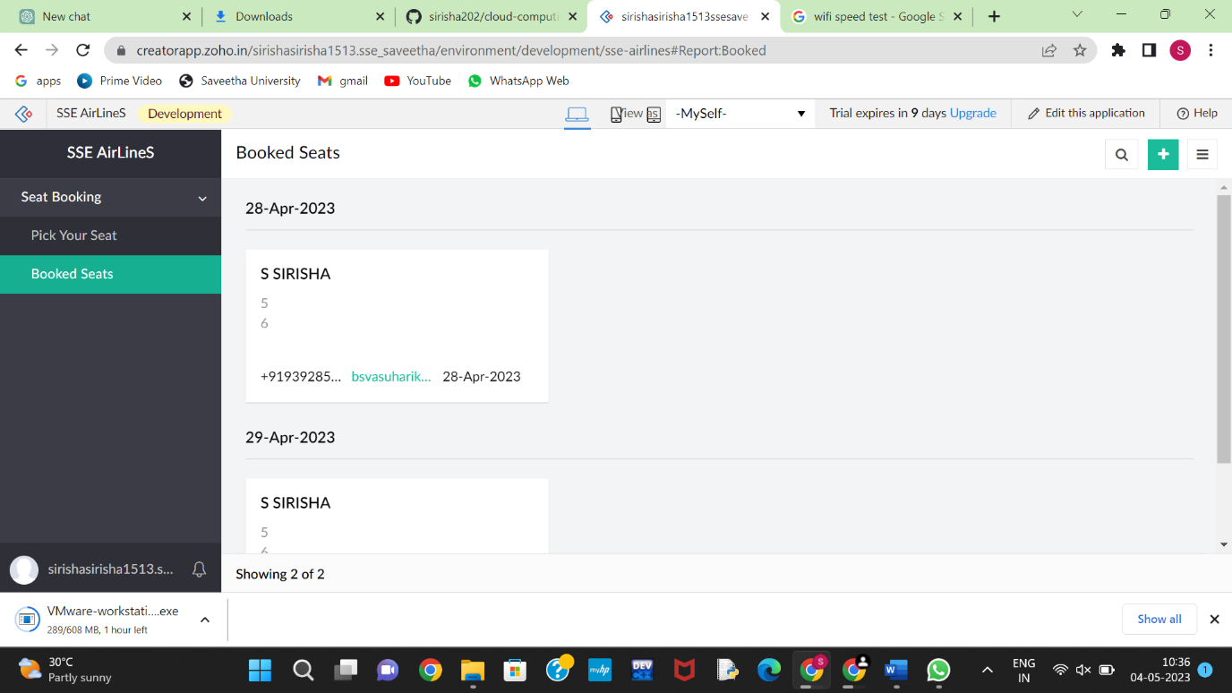

1. Create a simple cloud software application for Property Buying & Rental process (In Chennai city) using any Cloud Service Provider to demonstrate SaaS

**Solution:**

Select software:

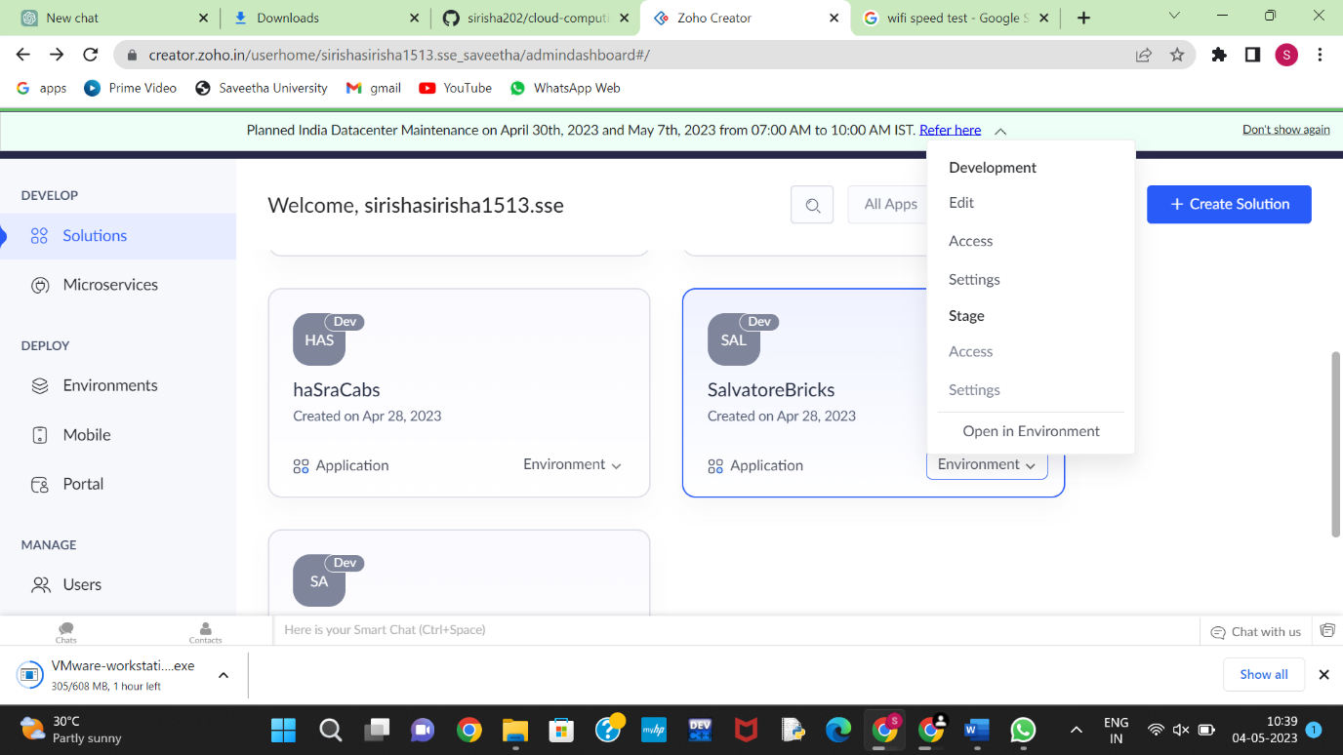

Application form:

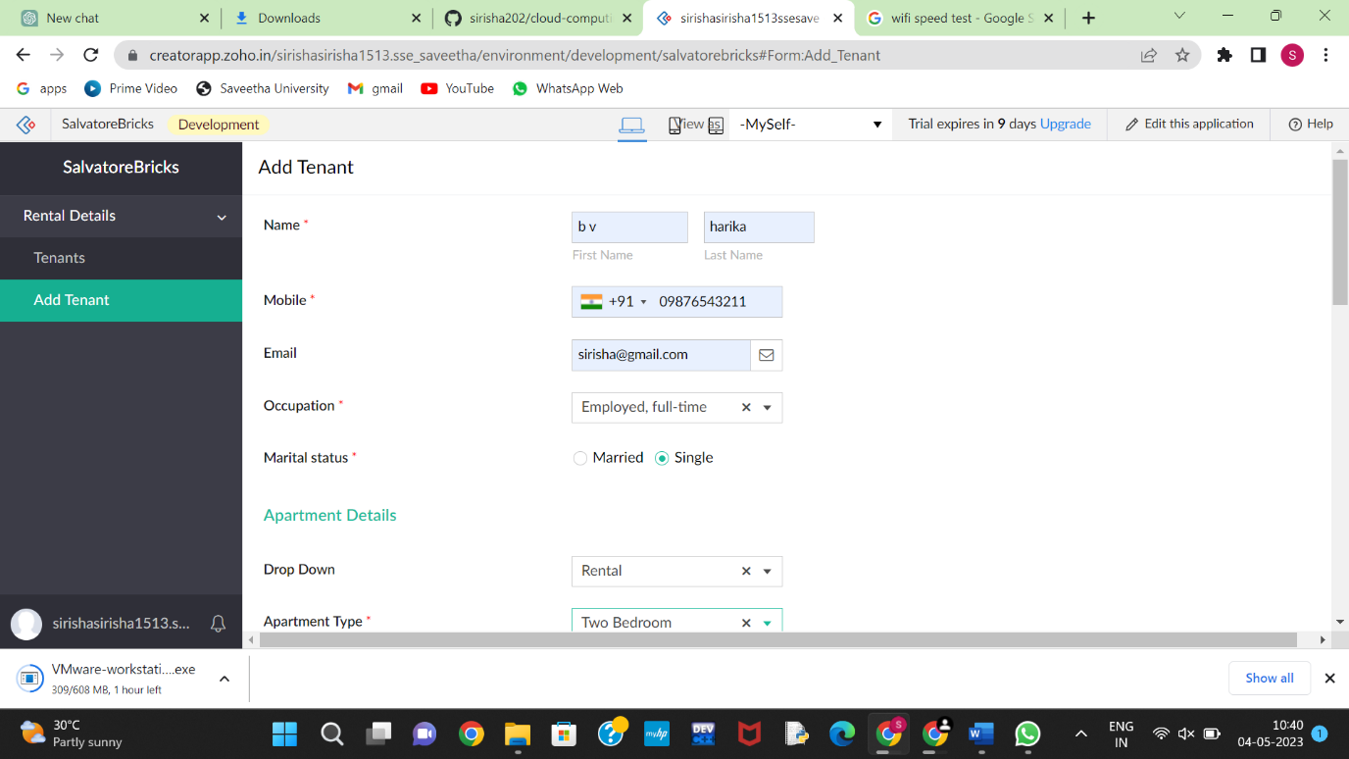

Output:

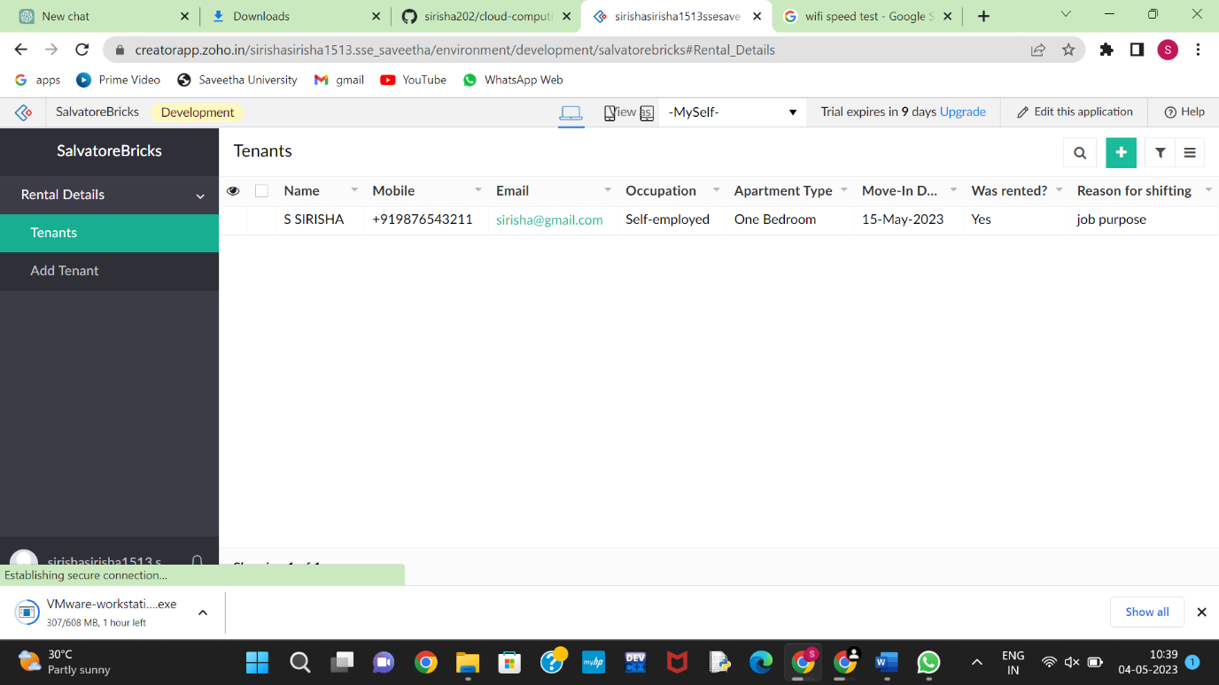

1. Create a simple cloud software application for Car Booking Reservation System using any Cloud Service Provider to demonstrate SaaS.

**Solution:**

Select the software:

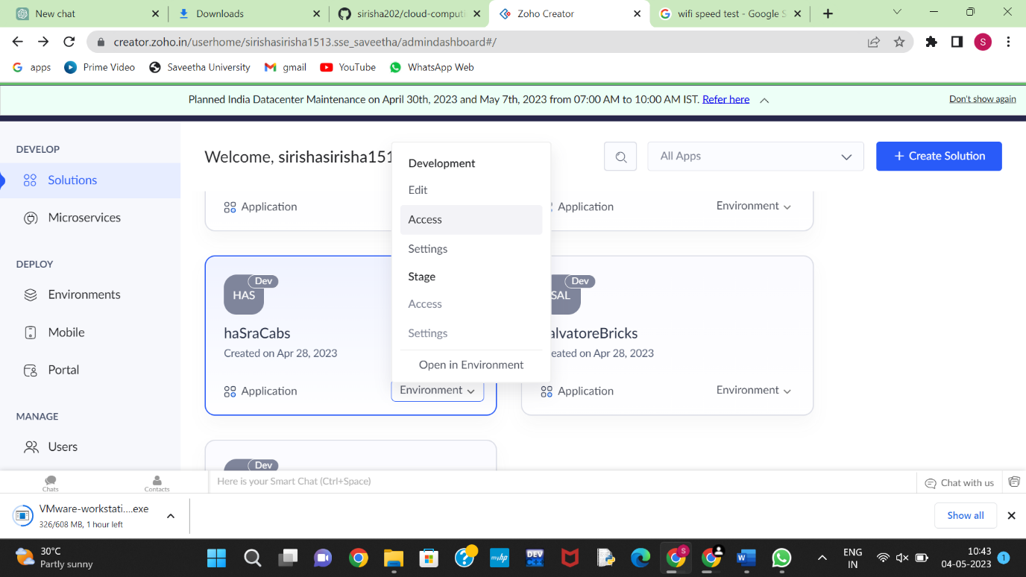

Application form:

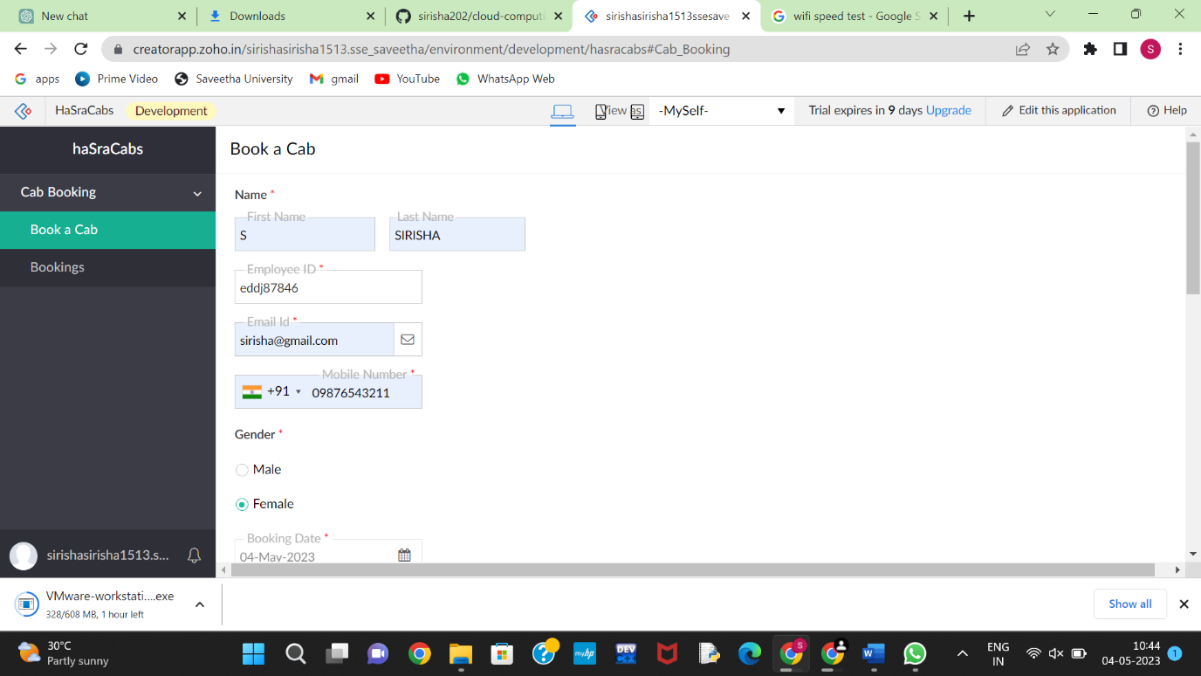

Output:

